Azure Bot Service

LUIS – Language understanding BOT

Conversation as a platform

Hackathon Guide

Content

1. Introduction
2. Prerequisite
3. Create Azure Bot Service
4. Create LUIS bot
5. Test the Bot
6. Delete the Bot
7. Next Steps
8. Links

**Introduction**

# **Language understanding bot**

The language understanding bot template shows how to use natural language models (LUIS) to understand user intent. When the user asks your bot to “get news about virtual reality companies,” your bot needs to understand what the user is asking for. [LUIS](https://www.luis.ai/) is designed to enable you to very quickly deploy an HTTP endpoint that will interpret the user’s input in terms of the intention it conveys (find news), and the key entities that are present (virtual reality companies). LUIS lets you custom design the set of intentions and entities that are relevant to the application, and then guides you through the process of building a language understanding application.

When you create the template, Azure Bot Service creates an empty LUIS application for you (that always returns None). You need to sign in to LUIS, click My applications, and select the application that the service created for you. Update your model by creating new intents, and then train and publish your LUIS app.

For information about using LUIS in the Bot Framework, see [Alarm Bot](https://docs.botframework.com/en-us/csharp/builder/sdkreference/dialogs.html#alarmBot).

The routing of the message is identical to the one presented in the [Basic bot template](https://docs.botframework.com/en-us/azure-bot-service/templates/basic/), please refer to that document for more info.

**Prerequisite**

Need Azure subscription and a resource group.

Permission to create Azure Bot Services and other related resources inside the assigned resource group.

Access to IT personnel who manages the Azure account in case of issues to troubleshoot.

If corporate logins are having issue, make sure the Live ID or MSDN Id can access the resource group.

Corresponding users should have contributor access to their resource groups.

**Create Azure BOT Service**

Step by Step instruction to Build LUIS Bot.

1. Open Edge or Chrome or other HTML 5 based browser
2. Go to the URL or Address Bar
3. <http://portal.azure.com>
4. You should see the login page

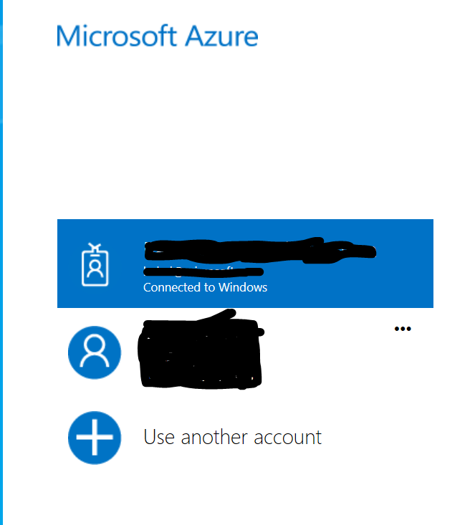

1. Login with your Corporate account or Live IT account
2. Now you should see the Portal Dashboard.
3. On the Left Menu item Select Resource Group

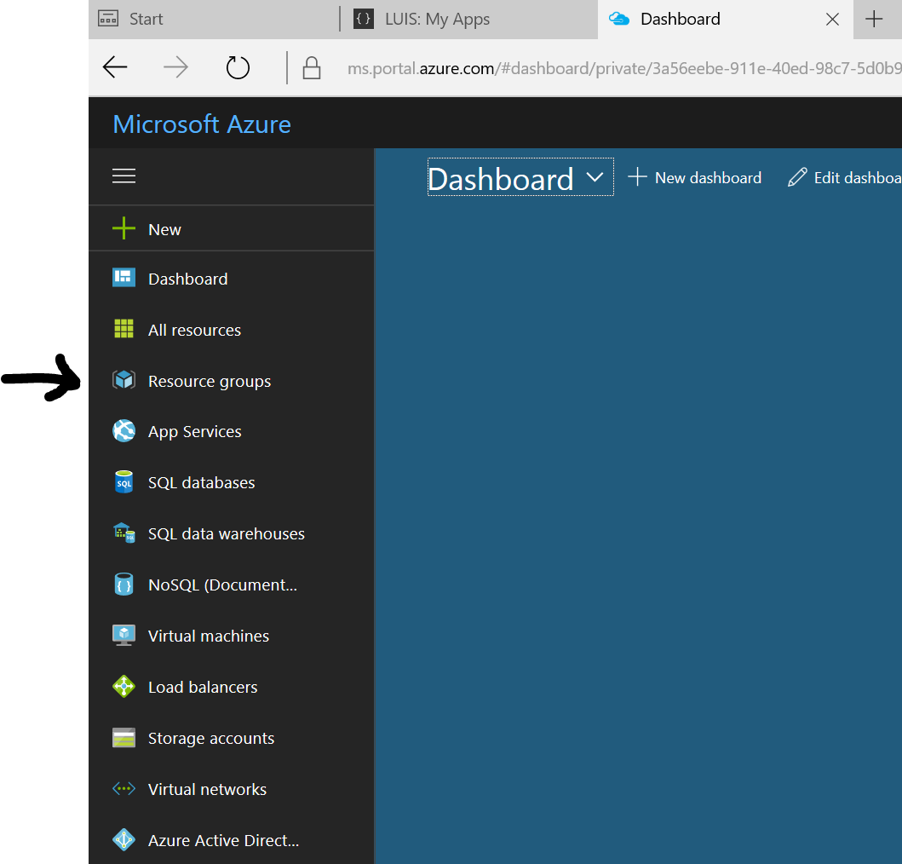

1. Click Resource Groups and should take you to List of available Resource group that you have permission for
2. Pick the resource group assigned to you for example



1. Click New to add Azure Bot Service

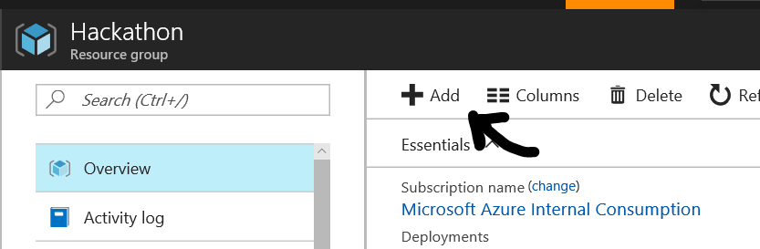

1. Search for Bot Service

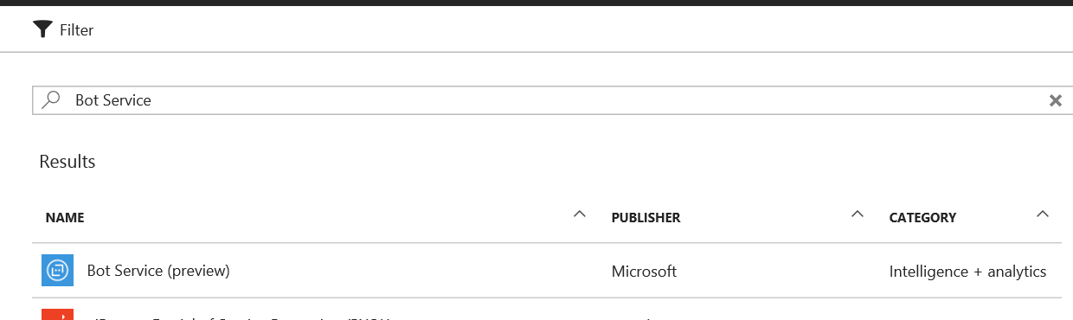

1. Select Bot Service
2. Click Create
3. 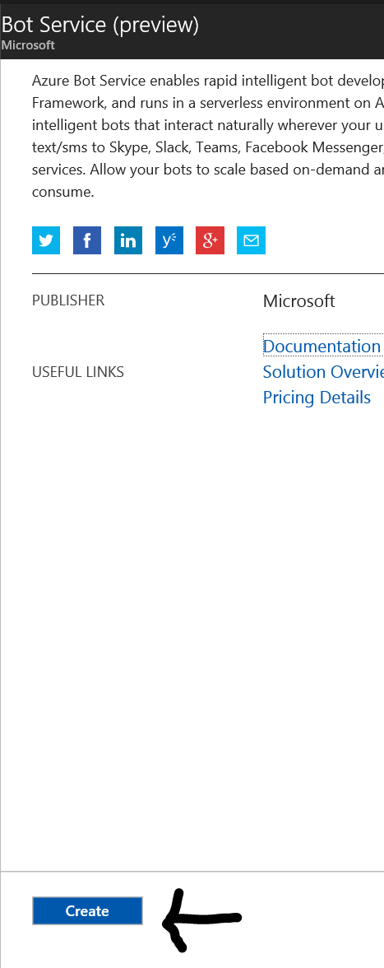
4. Lets Fill dome details like Application Name

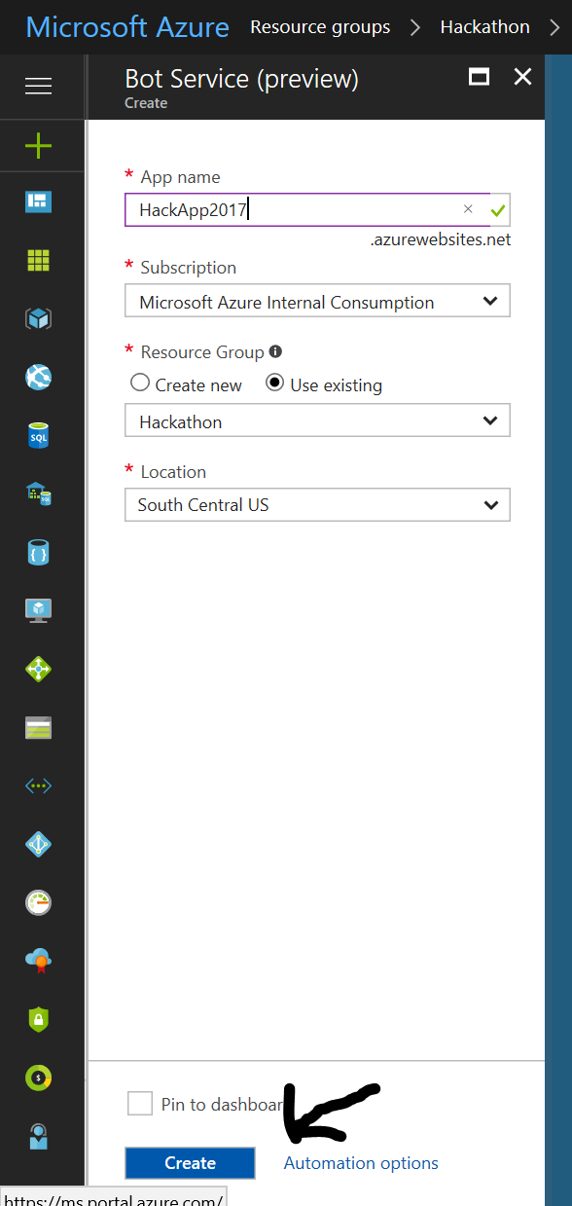

1. Select Subscription. This should be auto populated
2. Select the Resource group allocated.
3. Select the Location
4. Now Click Create
5. Once the resource is created you should be able to see the list of resource created in the resource group

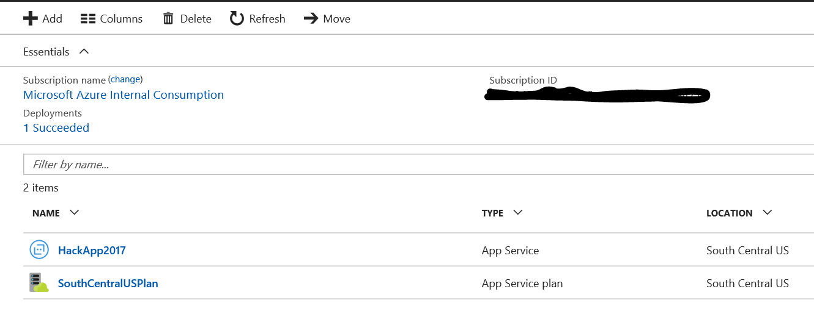

1. Now Click on HackApp2017
2. You should be able to see this

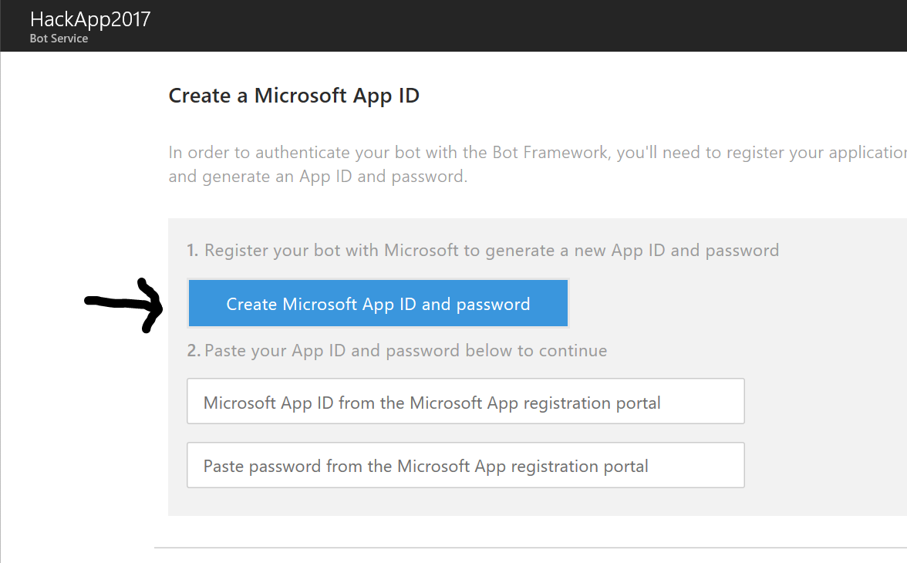

1. Login in with Live ID or Corporate ID
2. And should take you to a screen shown below
3. Click on Create Microsoft App ID and Password

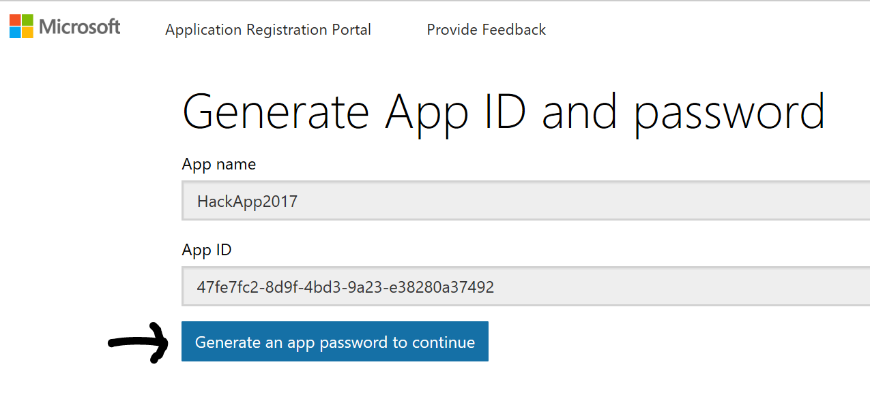

1. Save the App ID for future use
2. 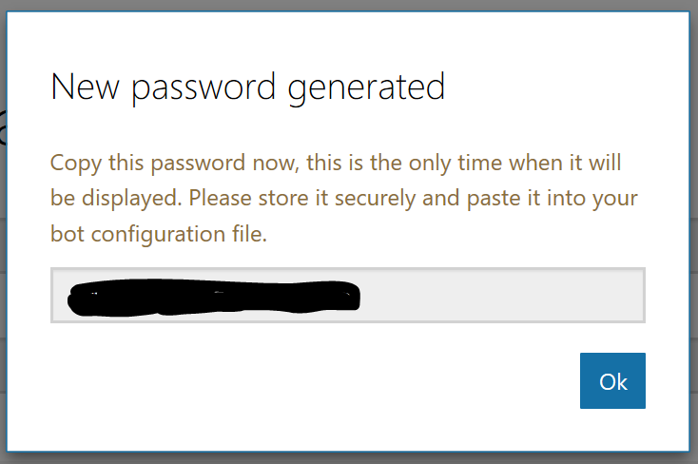
3. Copy the password should be saved in clipboard or a text file for future use
4. Now Click Finish and Go back to Bot Framework

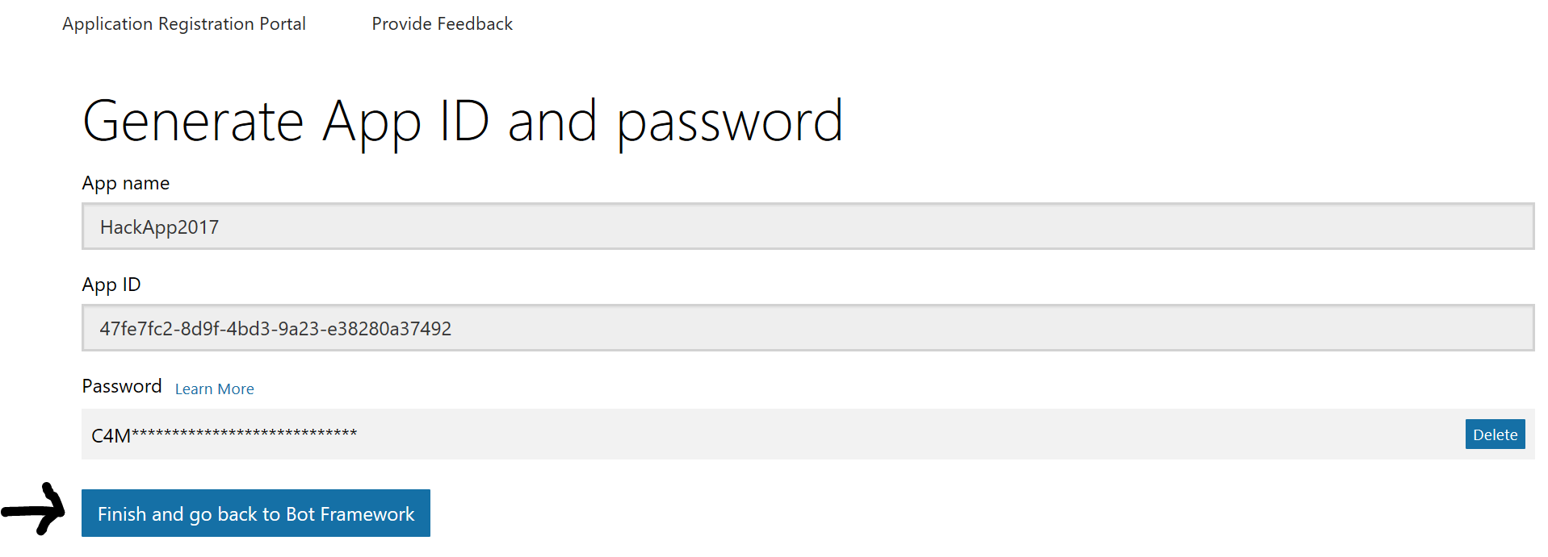

1. Now it should populate the app ID and password and you should be able to see this below

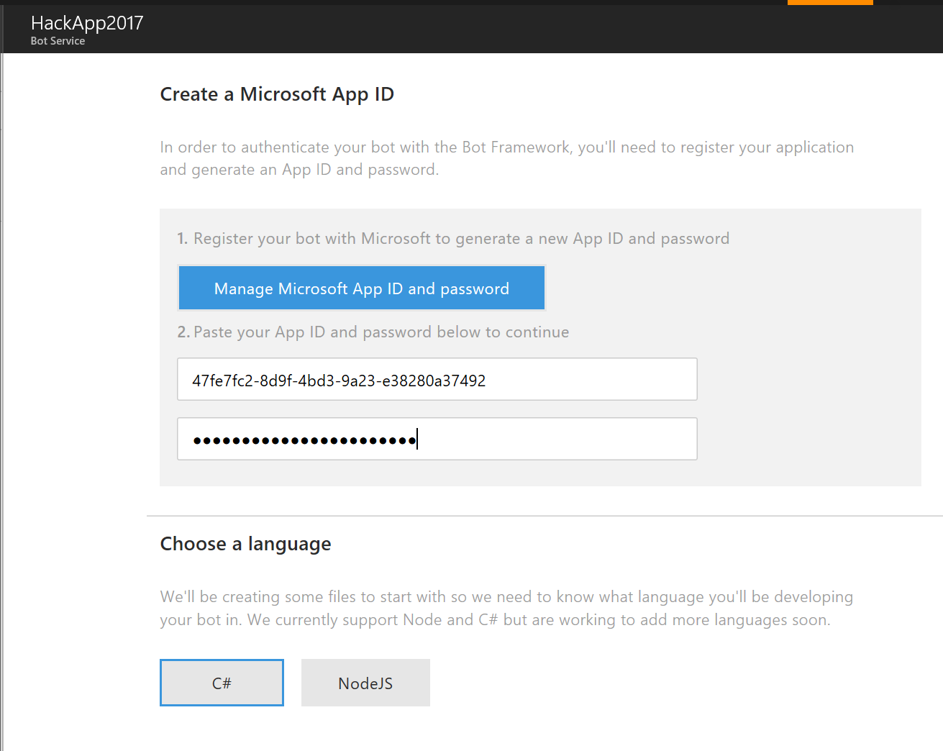

1. Select C#. But you can also select NodeIS
2. Now Scroll down
3. Until you see Language Understanding

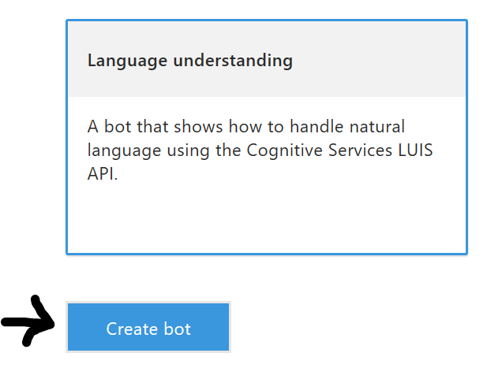

1. Click Create Bot

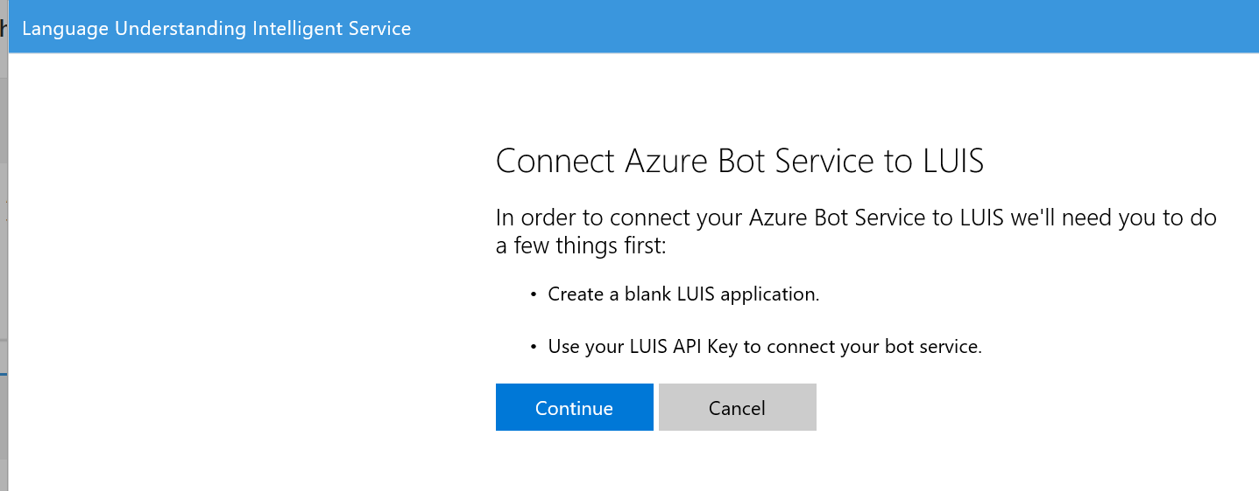

1. Cick Continue

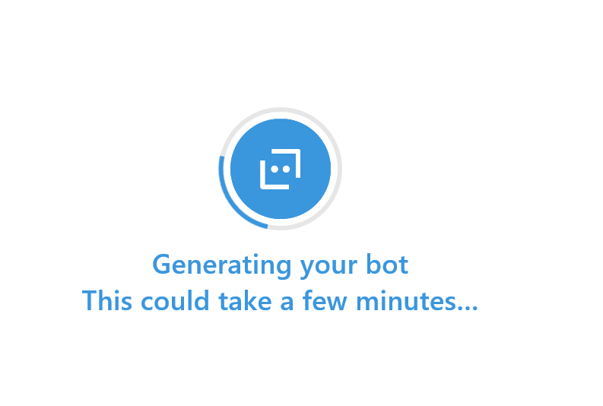

1. Will take a little time few secs or minutes to complete the process
2. Once the app is created
3. You should see a screen like

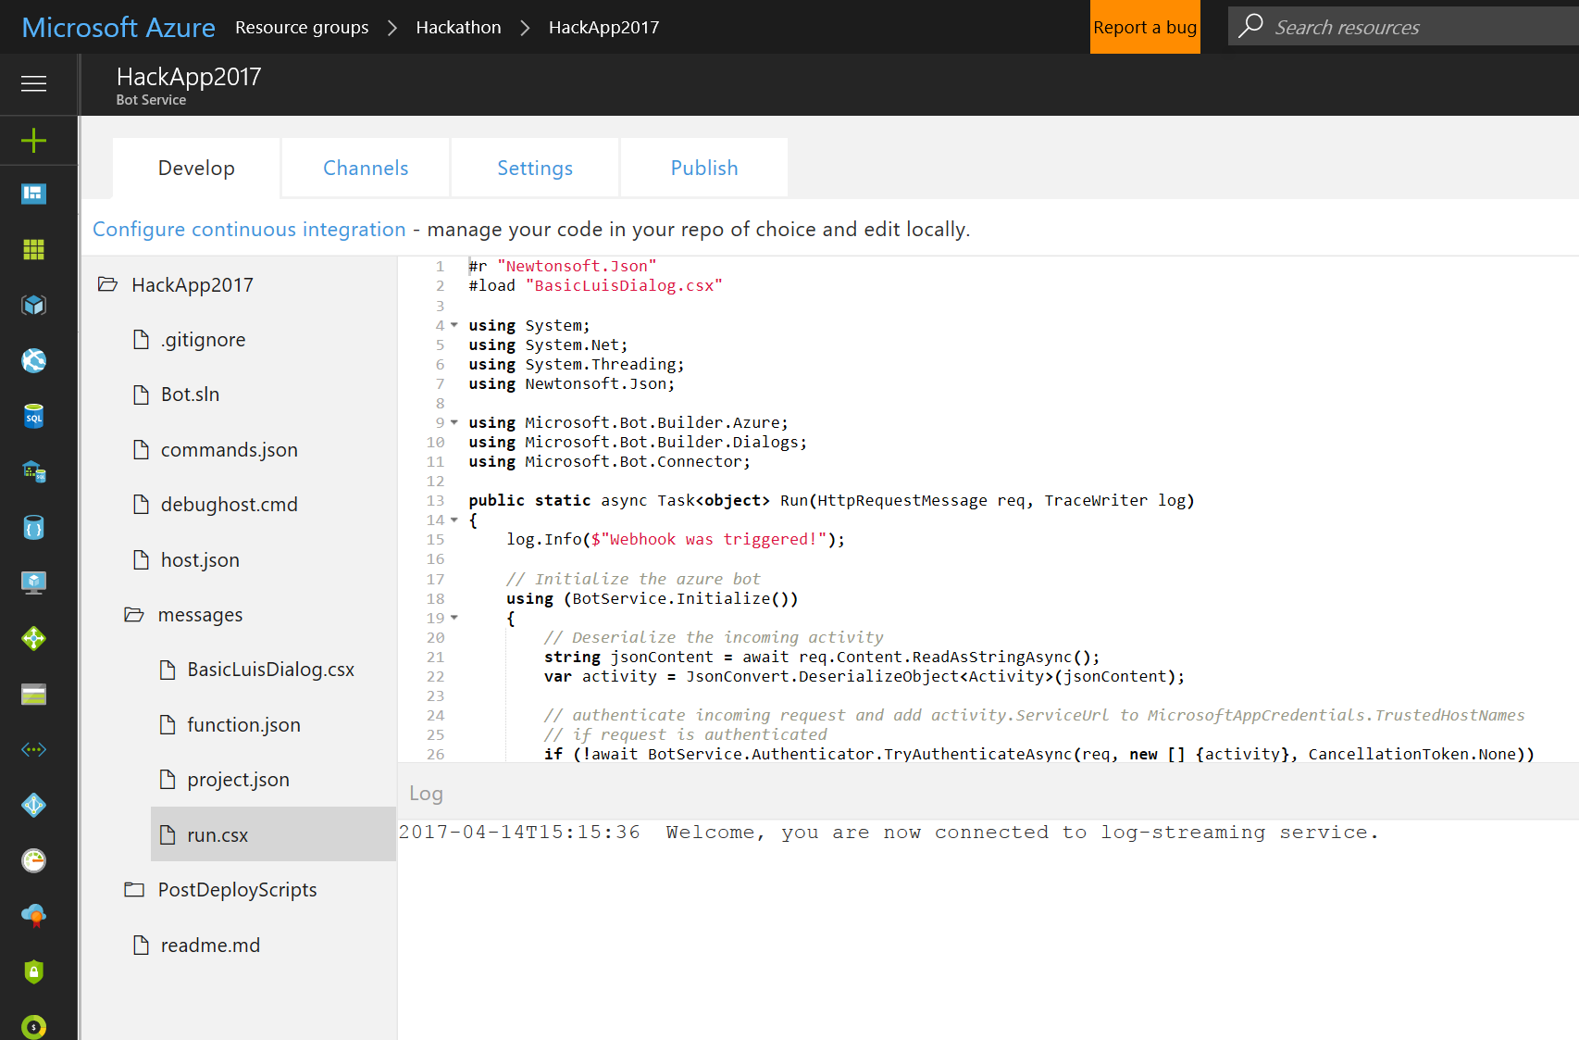

1. Now Go to Settings

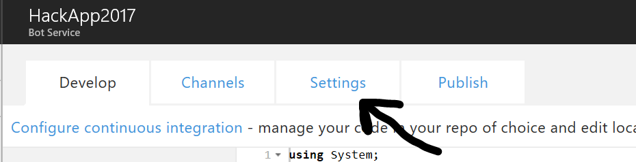

1. Now you should be able to see the settings screen
2. Scroll down to see Application Settings

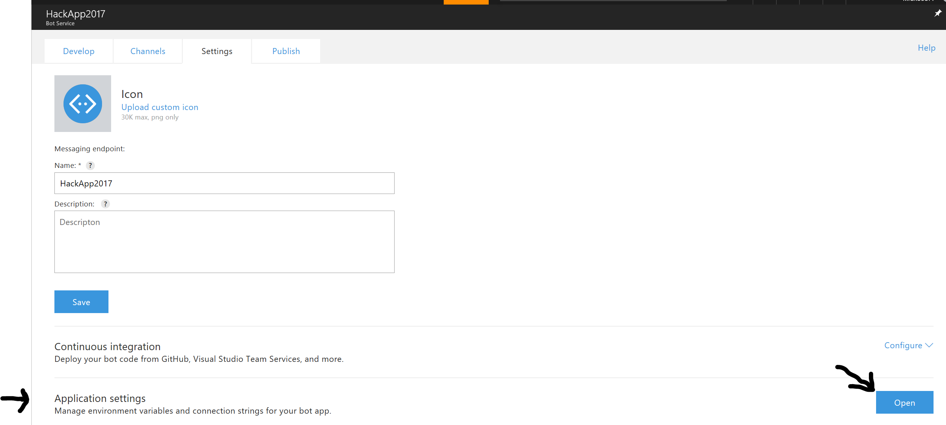

1. Click Open
2. Check and make sure the Settings for LUIS are already exsits. If exist do nothing. Else fill the details

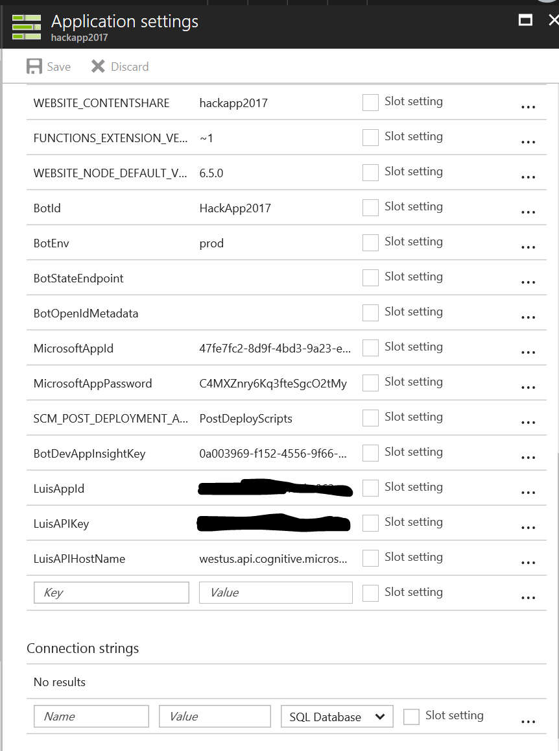

1. Check the LuisAppId and Luis APIKey

**Create LUIS Bot**

1. Now it is time to Go to Luis.ai to configure the Language Understanding Service
2. Go to <http://luis.ai>

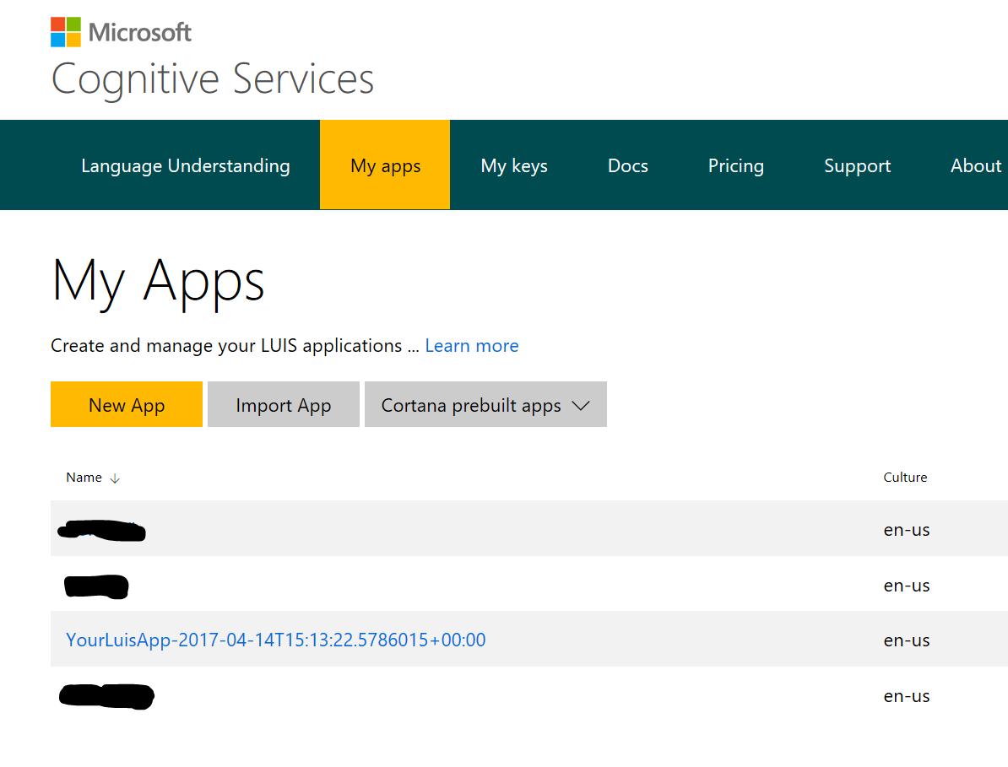

1. Click the YouLuisApp-2017….

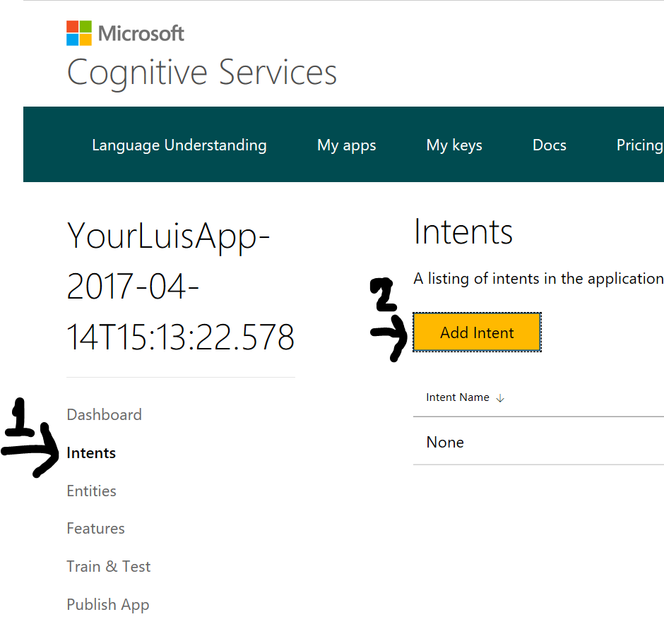

1. Click Intents
2. And Then Click Add Intent
3. Type in the Intent Name as Hackathon

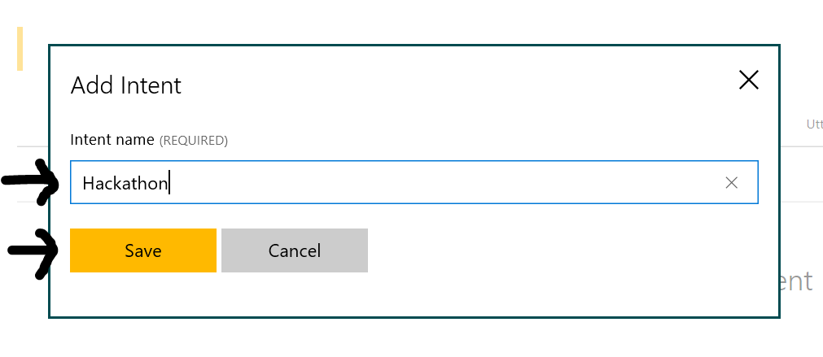

1. And then Click Save
2. Now Start typing in the Utterance and press ENTER key

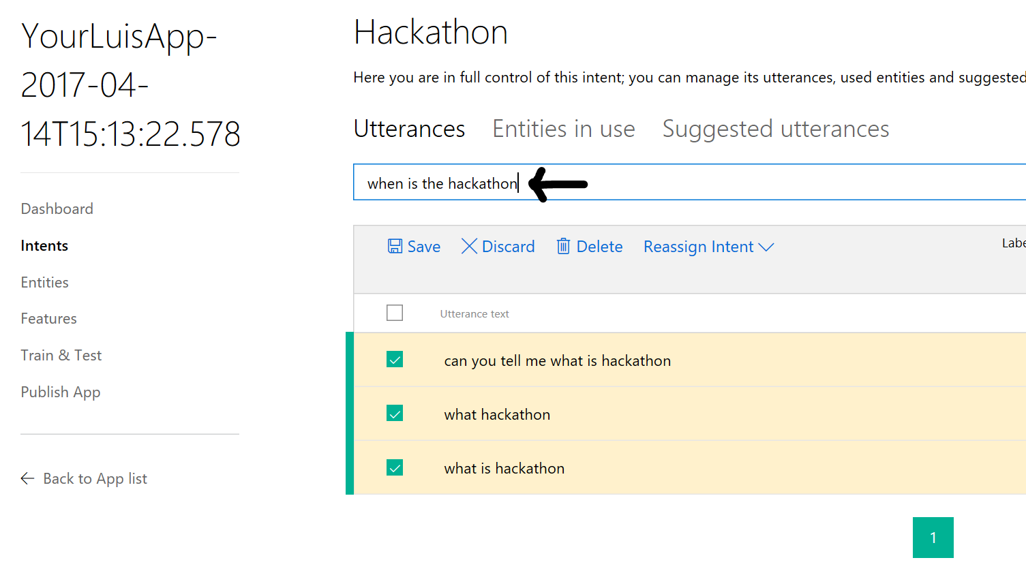

1. Once the Utterance are typed in then Click Save

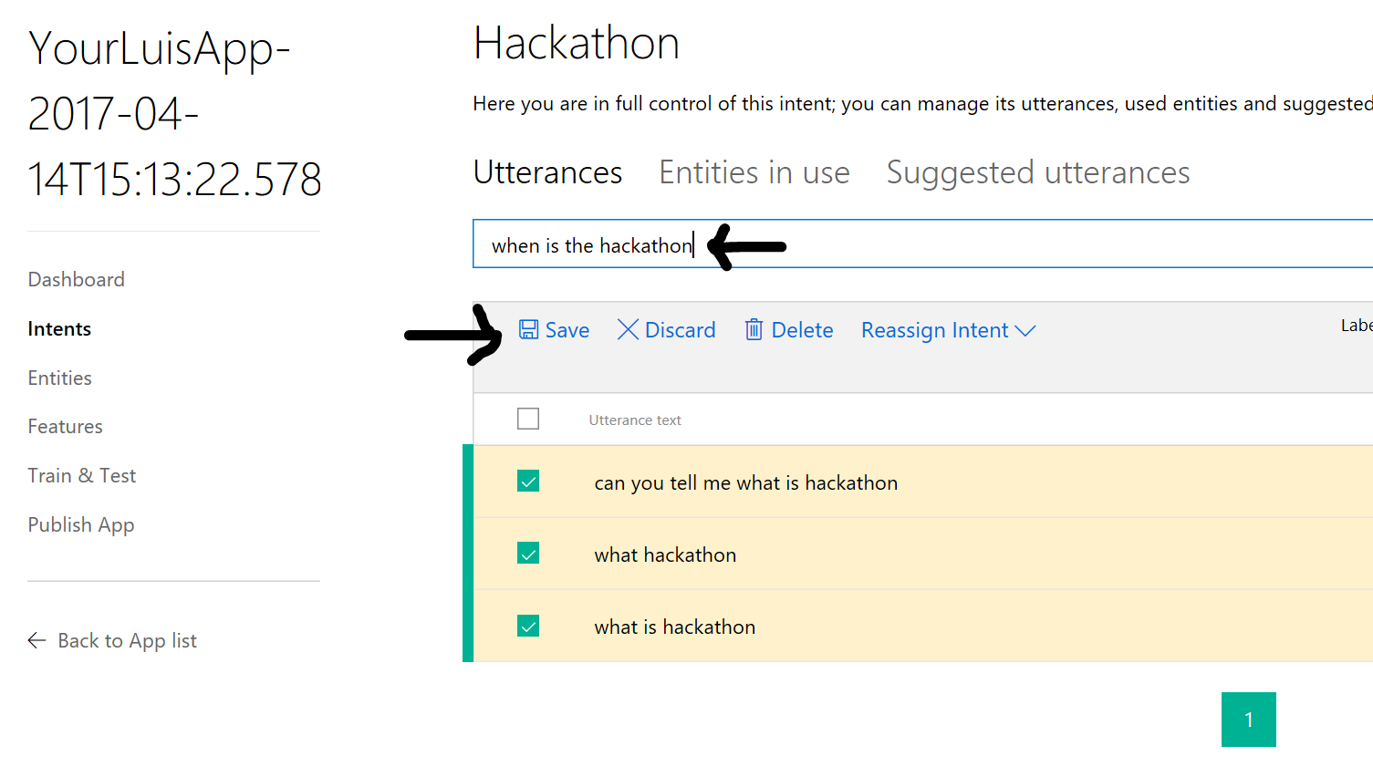

1. Now Click Entities on the left

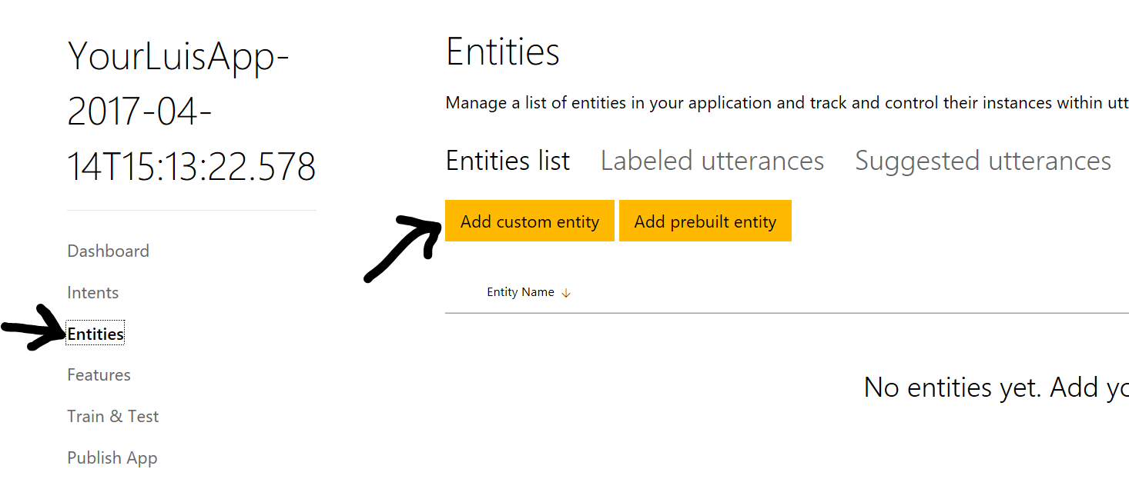

1. Add custom Entity

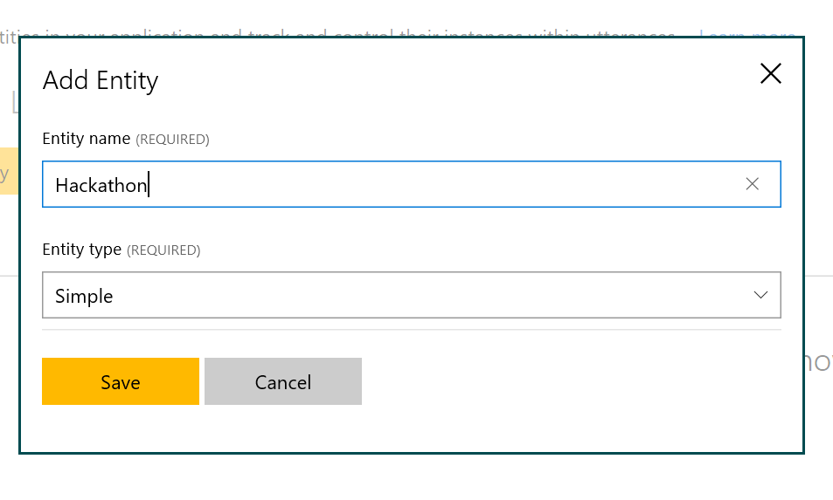

1. Click Save

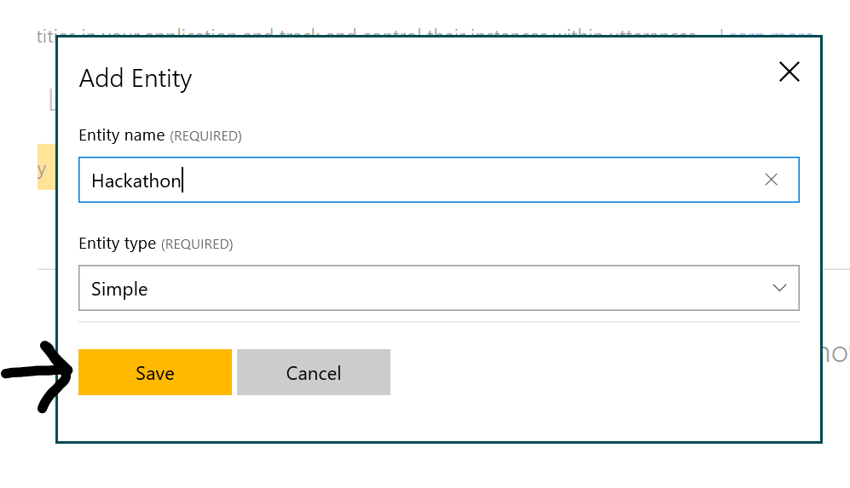

1. Once saved go back to Intent
2. 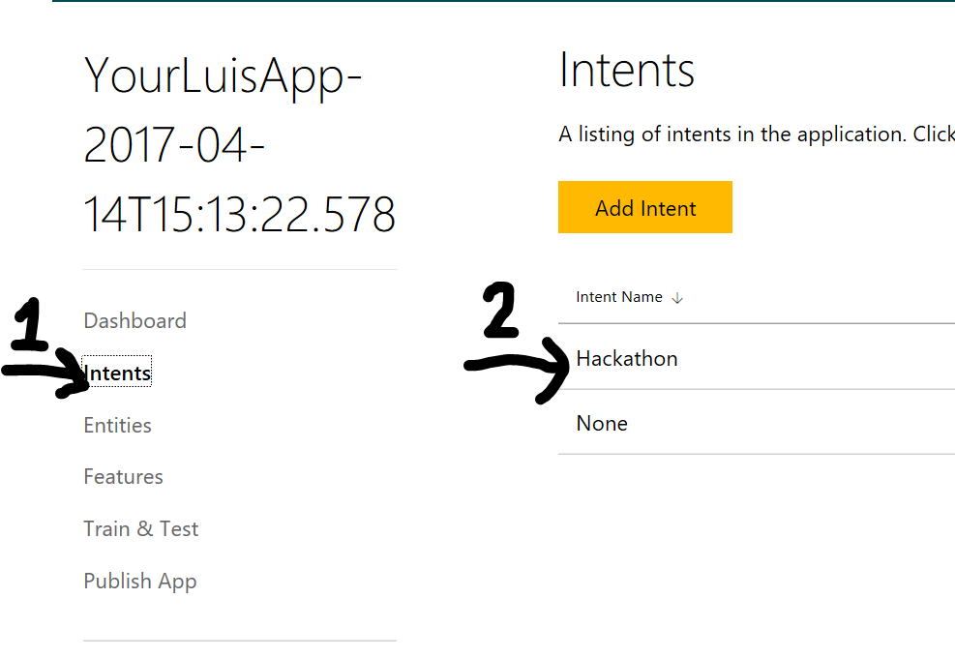
3. Click Intents
4. Click Hackathon
5. Select the Work Hackathon in the first utterance and then Click and it should popup with a drop down menu

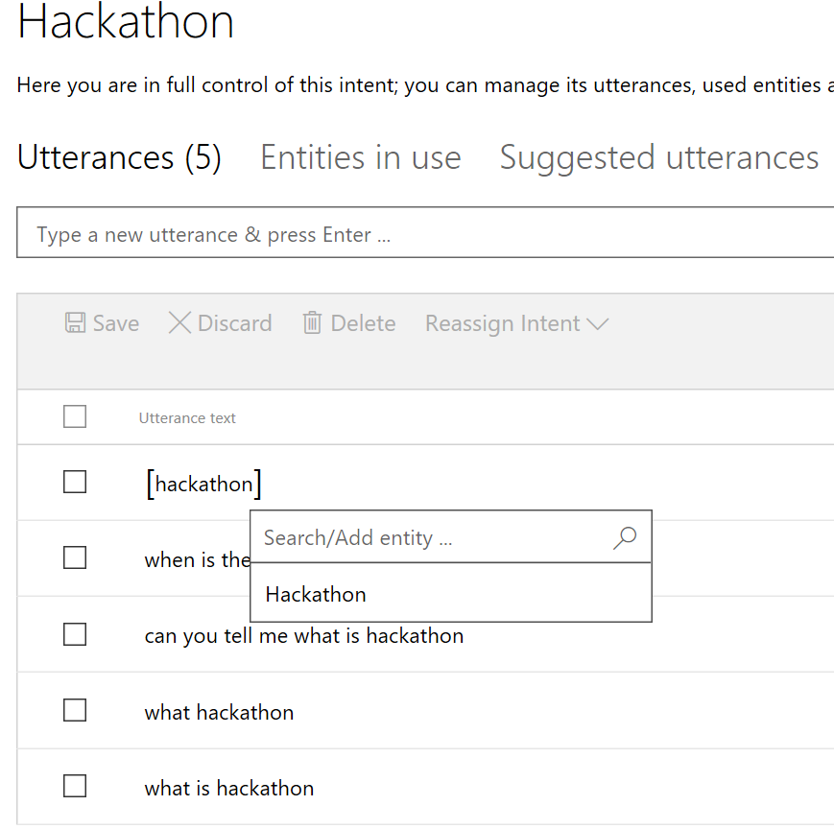

1. Do this for all the utterances
2. And should look like this

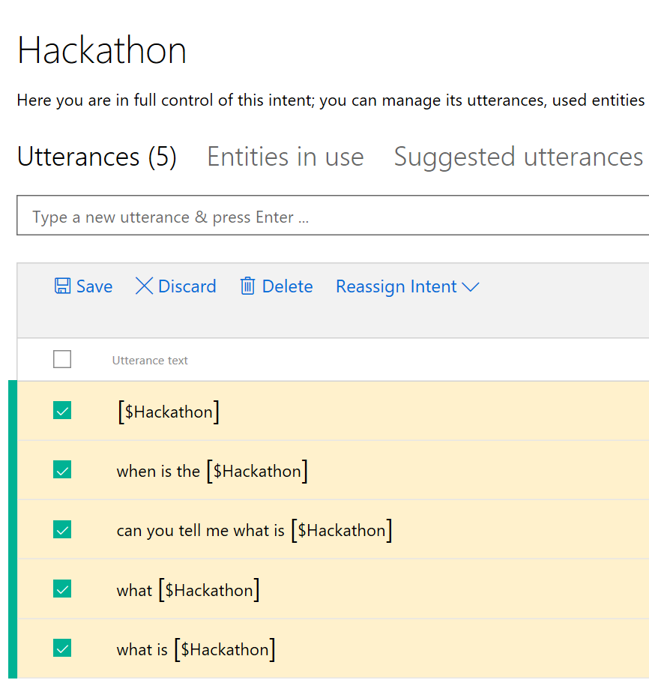

1. Now Click Save to Save the Entity linking

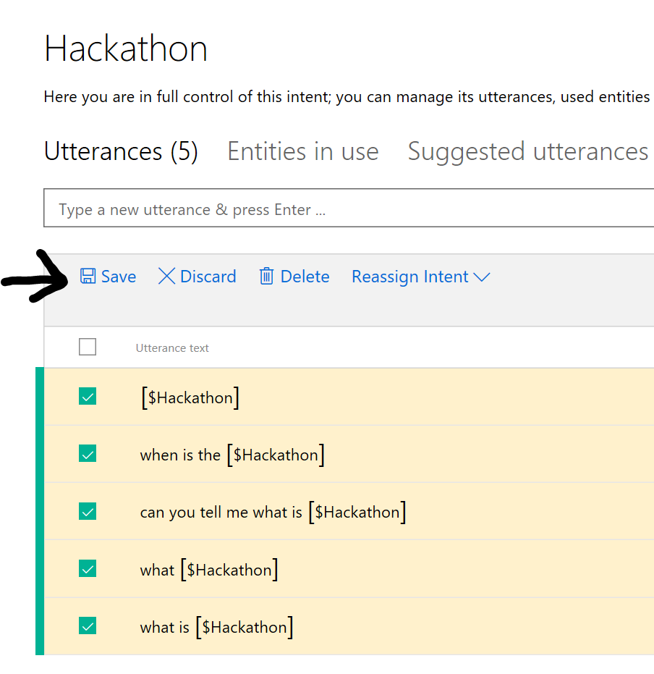

1. 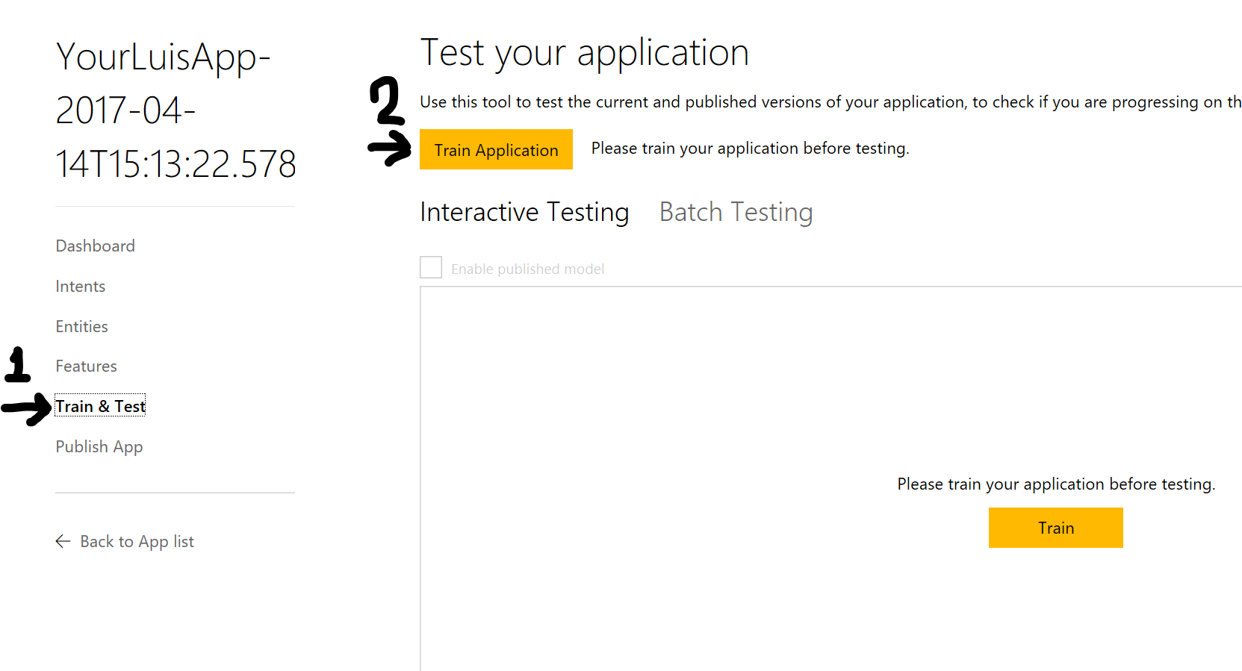
2. Click Train & Test and then Click Train Application
3. Once the training is complete

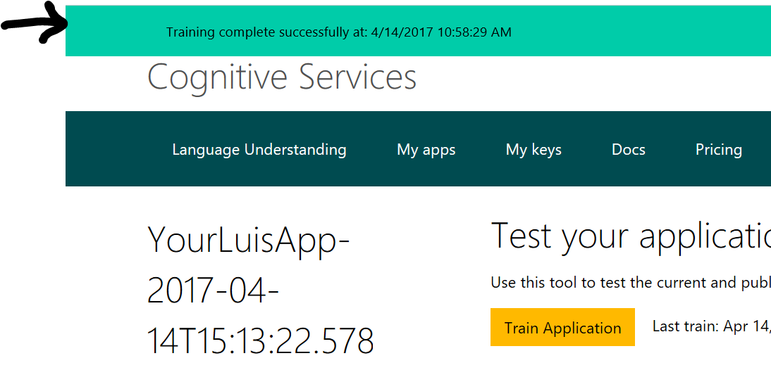

1. Then click Publish
2. 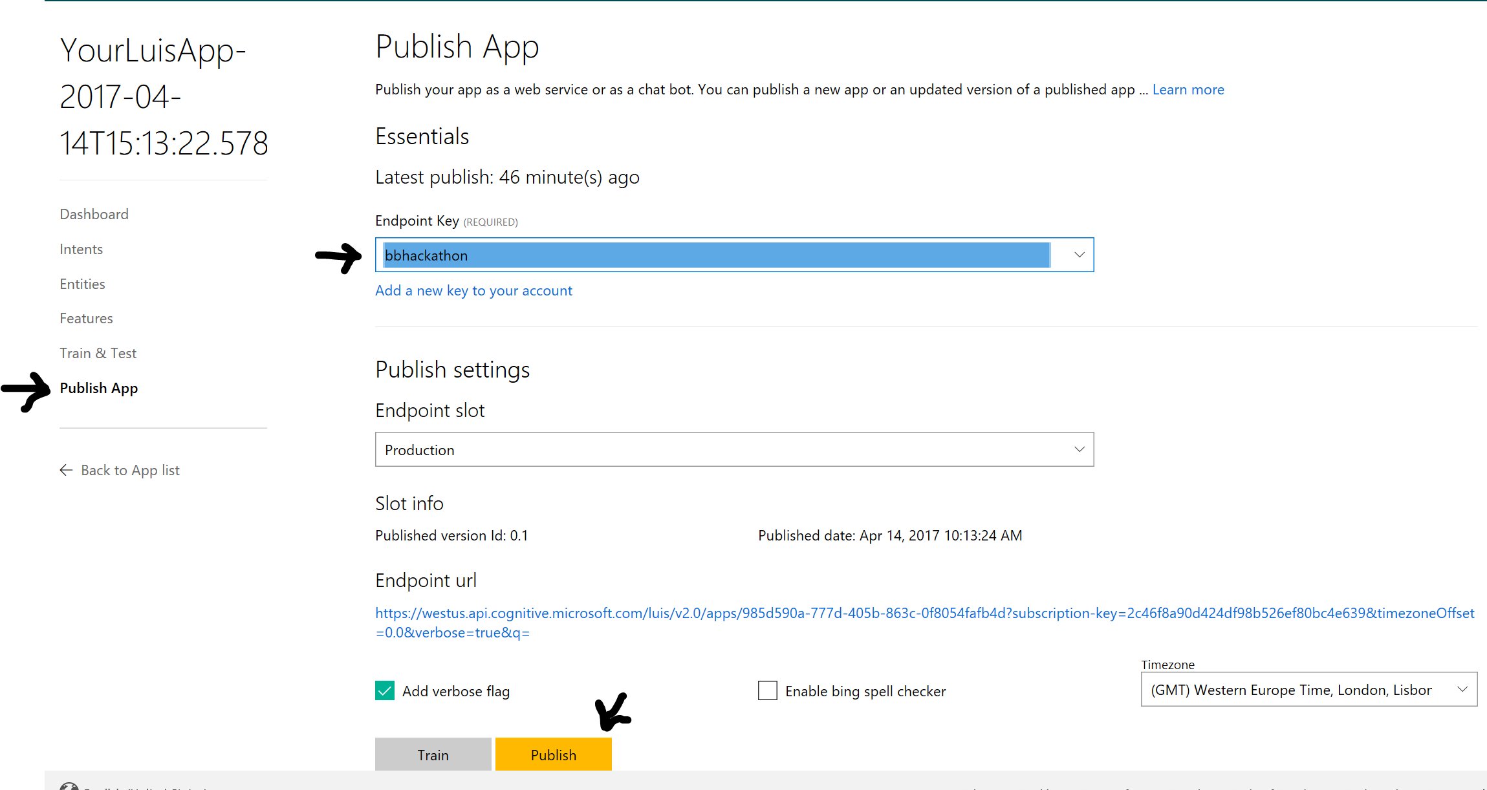
3. Select the Endpoint Key
4. And then click Publish
5. 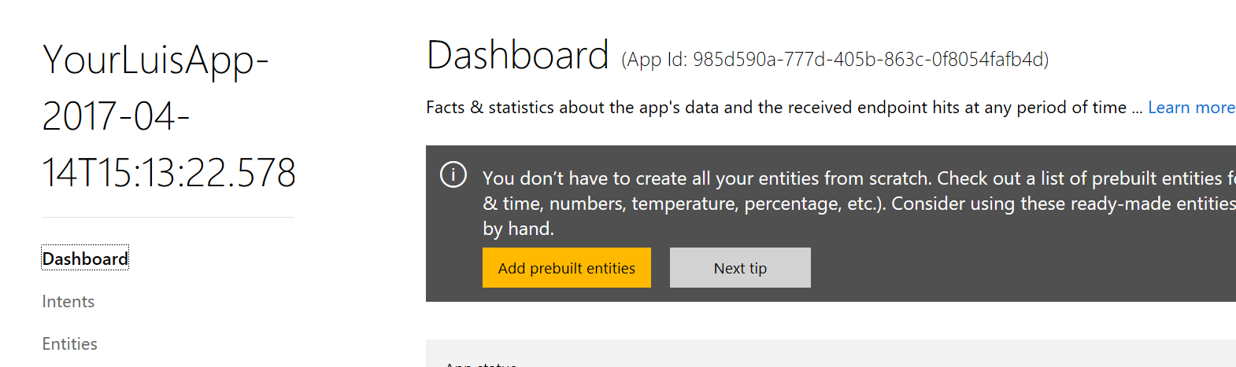
6. Now go back to Azure Portal
7. Go the Resource Group
8. You should be able to see the below

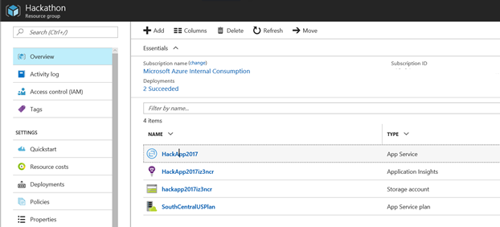

**Test the Bot**

1. Click HackApp2017

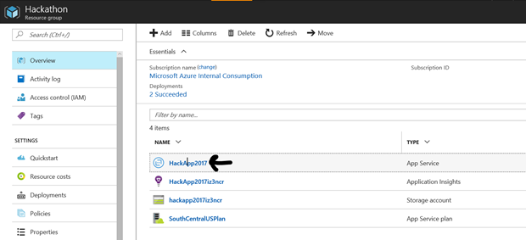

1. You should be able to view the Bot Code in the center pane and left pane should show you the Code files and Right Pane should load the Channel to communicate with bot

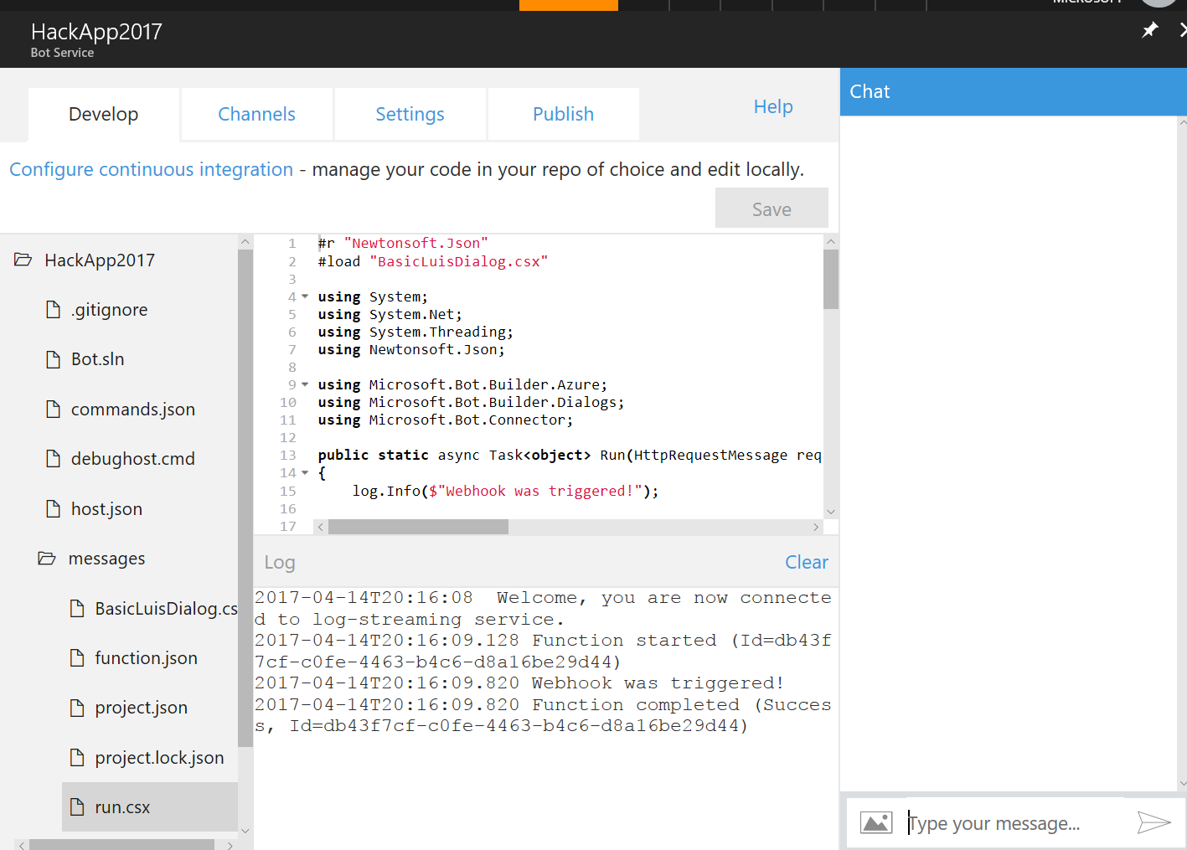

1. If you couldn’t see the Chat Box please try to clear cache and reload the portal page. Or Try another browser. The Bot has other channels that we can consume as well.
2. Start to Type Hi in the Chat windows where it says Type your message and press ENTER key

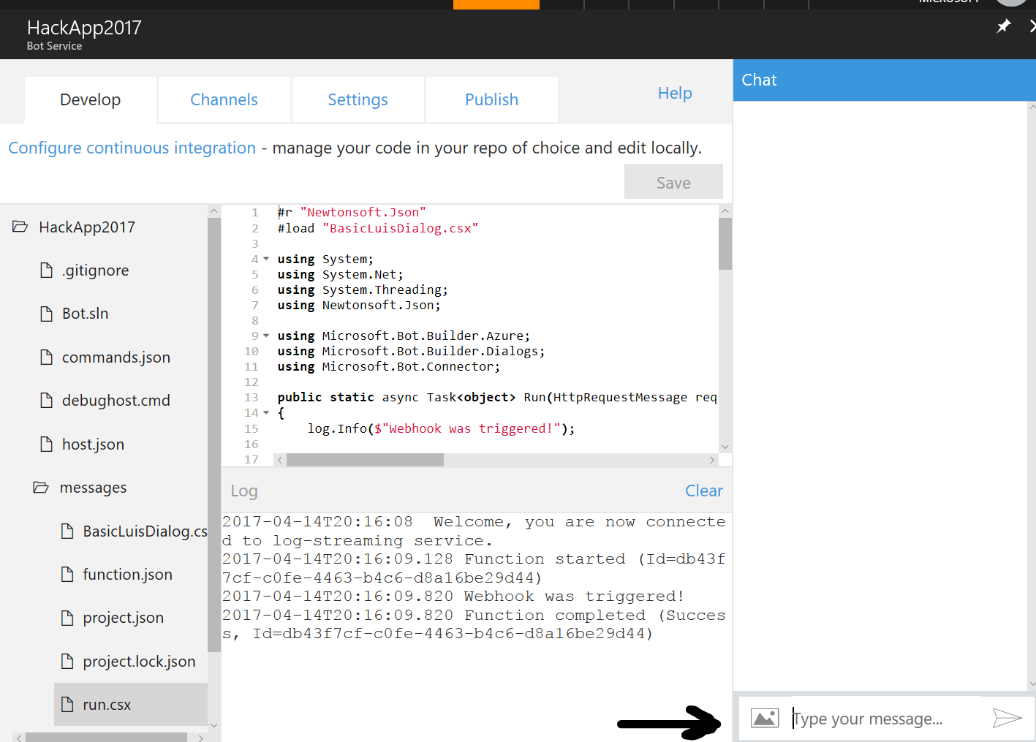

1. You can type What is Hackathon and the Bot will send the request to Luis and find the Intent and execute the corresponding Intent code in the bot framework.
2. 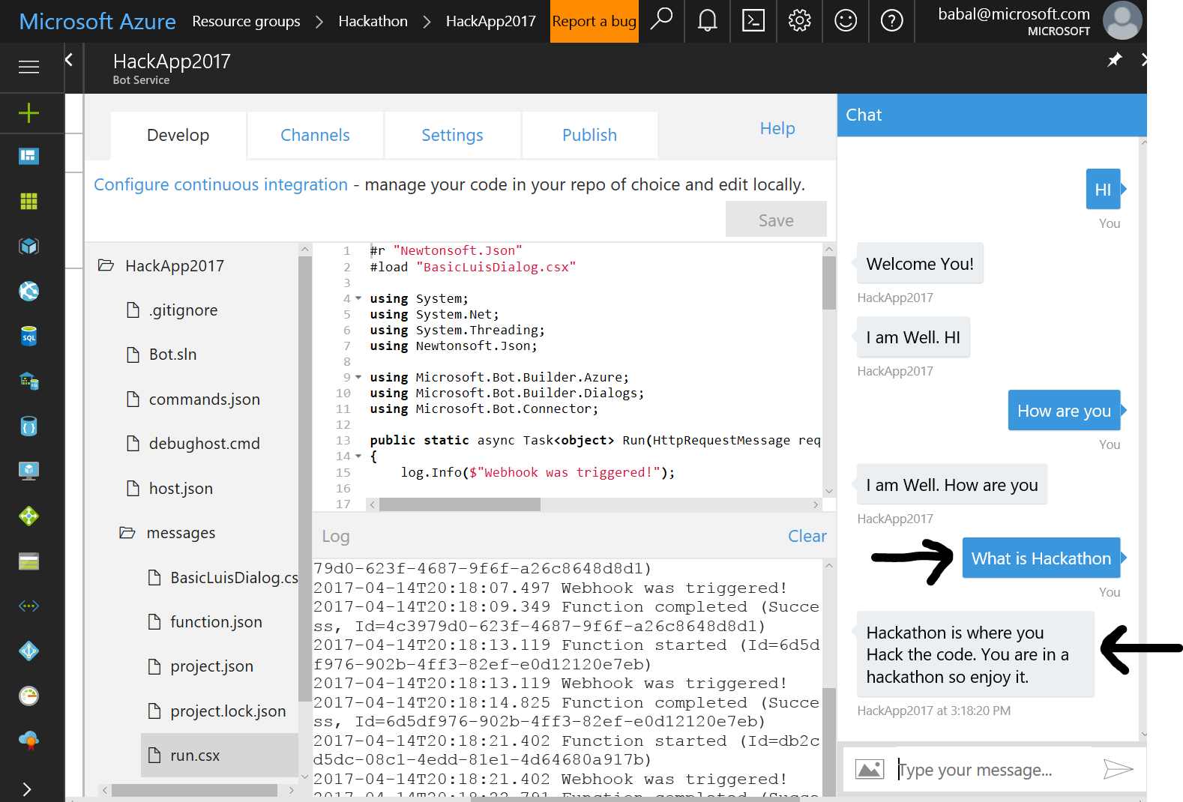
3. You can see the what you asked in ->
4. And the response from the bot <-. This allows us to create our own language.
5. In the Bot Code you can now write you business logic for what the users may ask.
6. Good luck and Congrats you have successfully built a NLP Bot using Cognitive Services API and the bot framework.
7. More information on backend.
   1. The Bot framework creates a WEB API.
   2. It Also creates App service plan and hosts the API.
   3. The API are REST API’s.
   4. Scalability can be handled by App service plan configuration
   5. The App also created application insights and logs any runtime errors and stats on the application as well for further investigation
8. Here are the other list of channels that bot can be consumed

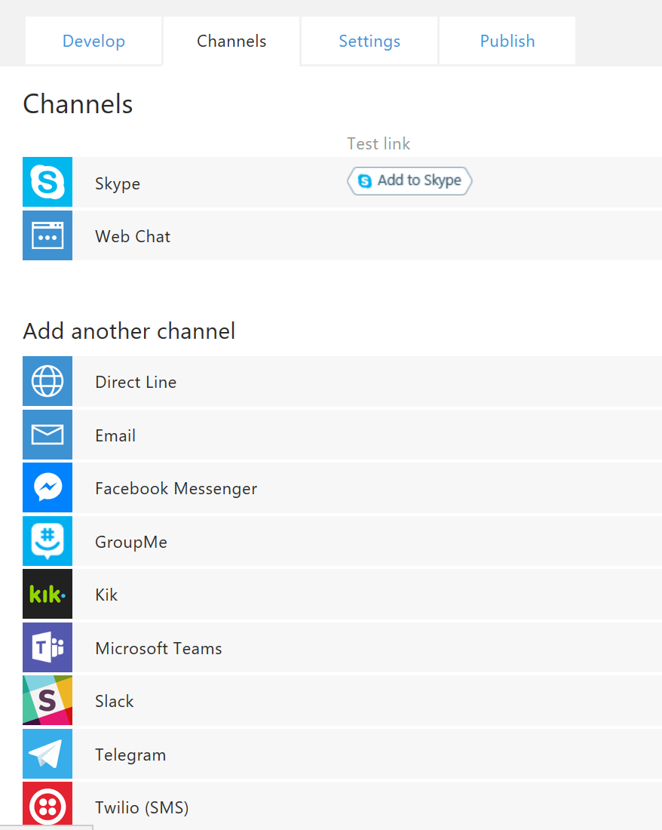

1. Skype and WebChat are more consumed.
2. WebChat will allow you to embed iframe code with the URL and Secret Key to your bot that you can embed the code in any HTML page of choice. The Page should have access to internet as the API is hosted in Azure in App Service
3. Here is a sample code from web chat when you enable the web chat.

<iframe src='https://webchat.botframework.com/embed/HackApp2017?s=YOUR_SECRET_HERE'></iframe>

1. The web chat will generate a secret key and use that instead YOUR_SECRET_HERE
2. Here is a sample web page that access the HackApp2017 bot.

<html>

<body>

<iframe src='https://webchat.botframework.com/embed/HackApp2017?s=YOUR_SECRET_HERE' width="400" height="500"></iframe>

</body>

</html>

1. Create a simple web page and copy the above code and paste and save it as “mybot.html”
2. Then open the html in any browser and you should be able to view the bot.
3. Edit the html code to adjust the size of the iFrame to make it big

**Delete the Bot**

1. Once you are satisfied with the outcome you may clean up the resource group.
2. Delete all the resources in the resource group from Azure portal.
3. Log into luis.ai and click My Apps and delete the luis application as well.



1. There is also option to download the Luis application JSON as well if you want to save to use that for Code repository as well.

**Next Steps**

1. Find simple use cases and start working in BOT
2. Create your own language understanding service and experiment with it
3. Have fun creating new innovative application
4. Give us feedback on the guide
5. Let us know what else you are interested in.

**Links**

[Bot Framework Resources Link](https://docs.botframework.com/en-us/)

[Luis.ai Documentation](https://www.luis.ai/home/help)